## PROGRAMMING IN PHPLAB(7MCE3C1)

1. **Get name of the user from a form and show greeting text.**
2. **Write a php program to check whether given number is palindrome or not.**
3. **Write a php program to check whether given number is Armstrong or not.**
4. **Write a php program to find largest values of two numbers using nesting of function.**
5. **Write a Mathematical calculator program.**
6. **Write a Age calculator program.**
7. **Write a php program to check whether given number is String palindrome or not.**
8. **Write a php program using function.**
9. **Create a PHP page for login page without sql connection.**
10. **Write a php program to Array manipulation.**
11. **Write a php program to design personal information**
12. **Create a PHP page for login page with sql connection.**
13. **Write a php program to Read from existing file.**
14. **Write a php program to Write a file**
15. **Write a php program to calculate Date and Time function .**
16. **Write a php program to design Curriculum Vitae.**
17. **Write a php program hit counter using cookies.**
18. **Create a web page to advertise a product of the company using images and audio.**
19. **Create a web page for Travel agency.**
20. **Create a web page for software company wesites. 21.Create a PHP page for login system using session.**

# GREETING TEXT

### AIM:

To write a program for get the name of the user from a form and show greeting text.

### PROGRAM:

**HTML FILENAME: Greet.html**

<html>

<head><style type="text/css">

div {font-size:20pt;color:green;font-family:Jokerman;text-align:center;width:30%} p{font-size:18pt;color:darkblue;font-weight:bold;align:center;font-family:arial black}

.double{border-style:double}

.dashed{border-style:dashed}

</style></head><body><center><br><br>

<div class="double">GREETING TEXT</div><br>

<div class="dashed"><form action="gre.php" method="post">

<p>Enter The Text:<br><input type="text" name="n"></p><br>

<input type="submit" value="&nbsp;&nbsp; SUBMIT &nbsp;&nbsp;">

<br></div></center></form></body></html>

### PHP FILENAME: Gre.php

<?php

$n1=$_POST['n'];

echo'<p><img src="4c.gif" alt="flower" style="float:right;">'; echo'<center><font color="green" face="arial" size="6">WELCOME</font>'; echo ‘<center><b> $n1 </b><font color="green">!!!</font></center>'; echo'<img src="4c.gif" alt="flower" style="float:left;"></p>';

?>

**OUTPUT**

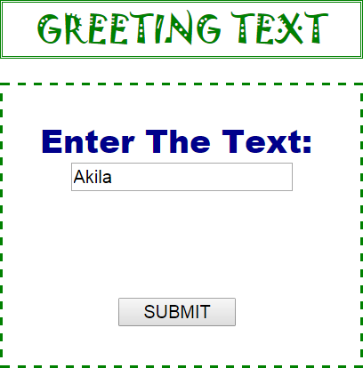



# PALINDROME CHECKING

### AIM:

To write a program for find the given number is palindrome or not.

### PROGRAM:

<html>

<body>

<form action="" method="post">

<br><center><h1><u><font color="red">PALINDROME</font></u></h1></center>

<br><table bgcolor="forestgreen" align="center">

<tr><td><br><input type="text" value=" Enter the Input" readonly>

<input type="text" name="n"></tr></td>

<tr><td><br><br><center><br><br>

<input type="submit" value="&nbsp;&nbsp; SUBMIT &nbsp;&nbsp;">

<br><br><br></center></tr></td></table>

</form>

<?php if($_POST)

{

$n1=$_POST["n"];

$p=$n1;

$s=0; while($n1>=1)

{

$r=$n1%10;

$n1=$n1*(10/100);

$s=$s*10+$r;

}

echo '<table align="center" border="2" width="46%"><tr align="center"><td><br>';

echo '<font color="forestgreen">'; if($p==$s)

echo"<h2> $p is Palindrome Number</h2>"; else

echo"<h2> $p is not Palindrome Number</h2>";

}

echo'</font>'; echo'</td></tr></table>';

?>

</body>

</html>

**OUTPUT**

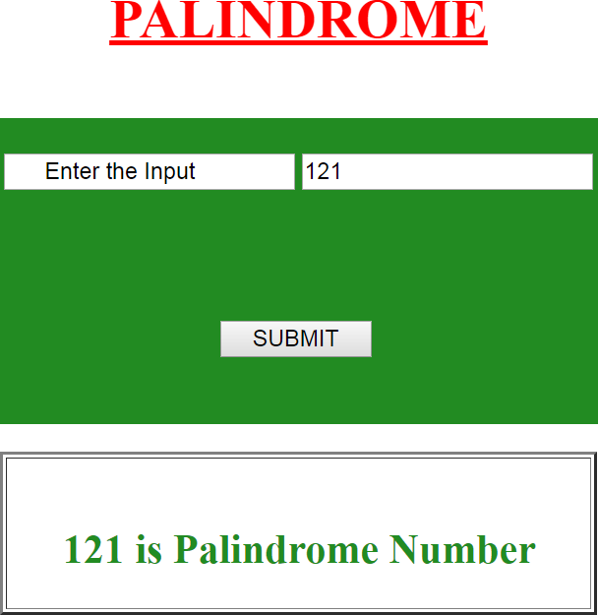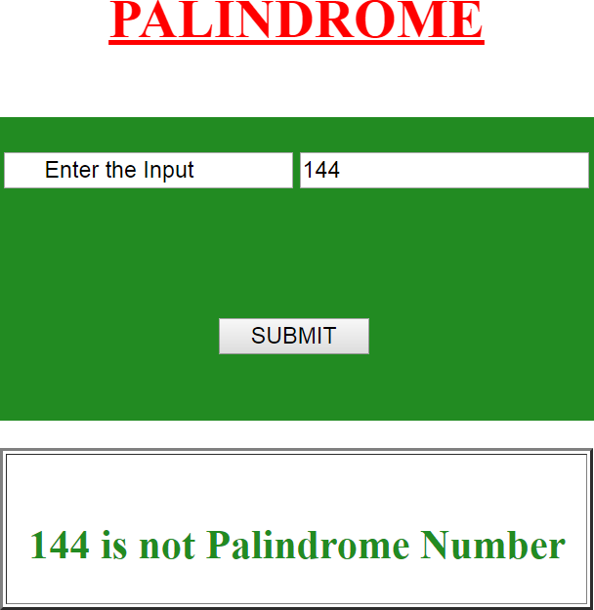

# ARMSTRONG NUMBER CHECKING

### AIM:

To write a program for find the given number is Armstrong or not.

### PROGRAM:

<html>

<body>

<form action="" method="post">

<br><center><h1><u>ARMSTRONG</u></h1></center>

<br><table bgcolor="Crimson" align="center">

<tr><td><br><input type="text" value=" Enter the Input" readonly>

<input type="text" name="n"></tr></td>

<tr><td><br><br><center><br><br>

<input type="submit" value="&nbsp;&nbsp; SUBMIT &nbsp;&nbsp;">

<br><br><br></center></tr></td></table>

</form>

<?php if($_POST)

{

$n1=$_POST["n"];

$m=$n1;

$s=0; while($n1>0)

{

$r=$n1%10;

$n1=$n1/10;

$s=$s+($r*$r*$r);

}

echo '<table align="center" border="2" width="38%"><tr align="center"><td><br>'; echo '<font color="Crimson">';

if($m==$s)

echo"<h2> $m is Armstrong Number</h2>"; else

echo"<h2> $m is not Armstrong Number</h2>";

}

echo'</font>'; echo'</td></tr></table>';

?>

</body>

</html>

**OUTPUT**

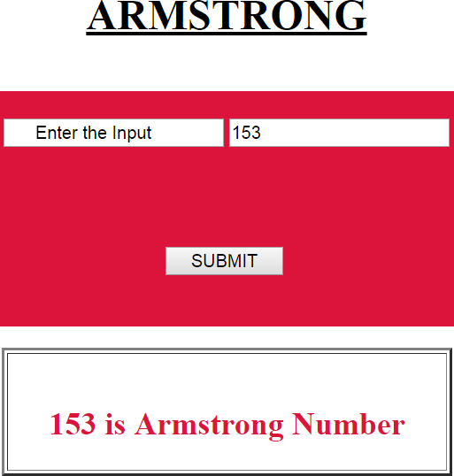

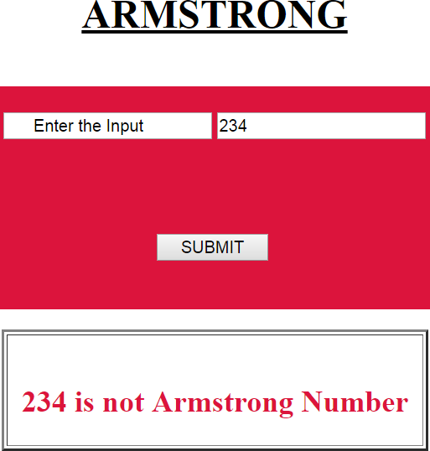

# NESTING OF MEMBER FUNCTION

### AIM:

To write a program for find the large value using nesting of member function.

### PROGRAM:

<?php if($_POST)

{

$a=$_POST['f'];

$b=$_POST['s']; function big($a,$b)

{ if($a>$b) return $a; else

return $b; } function large($a,$b)

{

$n=big($a,$b);

echo'<br><br><table align="center" border="3"><tr align="center"><td>'; echo'<h1><font color="darkblue">Nesting Function</font></h1>';

echo'<b><u>Given Values:</u></b><br><br>First Value &nbsp;&nbsp;&nbsp; =$a"; echo"<br>Second Value =$b";

echo'<br><h3><font color="darkred" face="cooper black">Large value ='; echo" $n</font></h3></td></tr></table>";

}

large($a,$b);

} ?>

**OUTPUT**

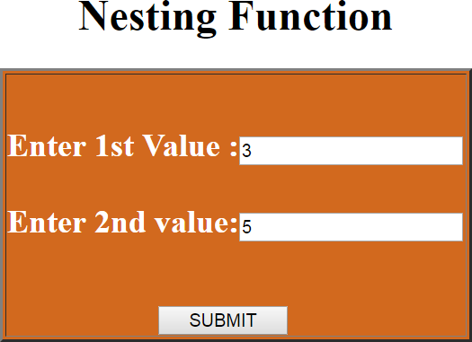

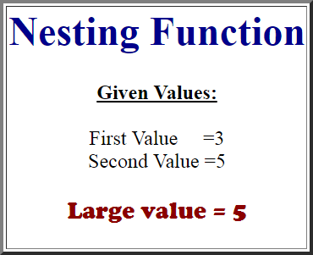

# MATHEMATICAL CALCULATOR

### AIM:

To write a program for mathematical calculator.

### PROGRAM:

<?php if(isset($_POST['disp']))

{

$f=$_POST['f'];

$s=$_POST['s'];

$ch=$_POST['ch']; switch($ch)

{

case 'ADDITION':

$res=$f+$s; break;

case 'SUBTRACTION':

$res=$f-$s; break;

case 'MULTIPLICATION':

$res=$f*$s; break;

case 'DIVISION':

$res=$f/$s; break;

}

}

?>

<html>

<body bgcolor="gold">

<form action="" method="post">

<table align="center" border="3" width="20%"><br><br>

<tr bgcolor="forestgreen"><td align="center" colspan="2">

<font color="white" face="arial black" size="5">CALCULATOR</font></td></tr>

<tr><td><input type="button" value="Enter First Input "></td>

<td><input type="text" name="f"></td></tr>

<tr><td><input type="button" value="Enter Second Input"></td>

<td><input type="text" name="s"></td></tr>

<tr><td><input type="button" value="Select Your Choice"></td>

<td><center><select name="ch">

<option>ADDITION</option>

<option>SUBTRACTION</option>

<option>MULTIPLICATION</option>

<option>DIVISION</option>

</center></select></td></tr>

<tr><td><input type="submit" value=" RESULT " name="disp"></td>

<td><input type="text" value="<?php echo @$res; ?>" readonly="true"/>

</td></tr></table>

</body></html>

**OUTPUT**

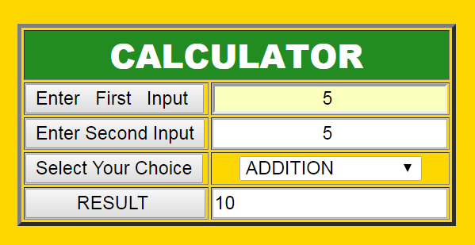

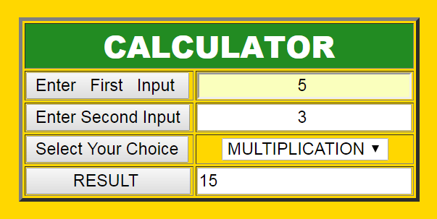

# AGE CALCULATOR

### AIM:

To write a PHP program for age calculation.

### PROGRAM:

<?php error_reporting(1);

$day=0;

$yr=0;

$mon=0; if(isset($_POST['b1']))

{

$d1=$_POST['t1'];

$d2=$_POST['t2'];

$arr=explode("/",$d1);

$brr=explode("/",$d2); if($arr[0]<$brr[0])

{

$arr[0]+=30;

$arr[1]-=1;

}

$day=$arr[0]-$brr[0]; if($arr[1]<$brr[1])

{

$m1+=12;

$arr[2]-=1;

}

$mon=$arr[1]-$brr[1];

$yr=$arr[2]-$brr[2];

}

?>

<html>

<body><form method="POST">

<table border="2" align="center" bordercolor="darkviolet"><tr><br><br><br>

<td align="center" colspan="2" bgcolor="darkviolet"><font color="white">

<br><h2><b>AGE CALCULATOR</b></h2></font></td></tr>

<tr><td align="center"><b>Enter current date</b></td>

<td align="center"><input type="text" name="t1" autofocus></td></tr>

<tr><td align="center"><b>Enter &nbsp;&nbsp;Your DOB</b></td>

<td align="center"><input type="text" name="t2"></td></tr>

<tr><td align="center" colspan="2"><input type="submit" name="b1" value="calculate"

</td></tr><tr><td align="center"><b>Your Age </b></td>

<td align="center">

<?php error_reporting(1);

echo $yr.'years'.$mon.'months'.$day.'days'; echo'</font>';

?>

</td></tr></table></form></body></html>

**OUTPUT**

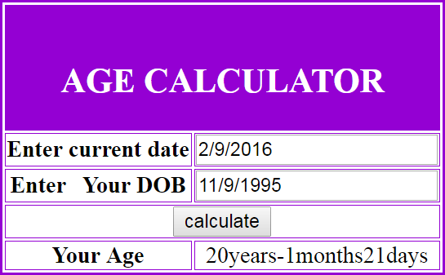

# STRING PALINDROME

### AIM:

To write a program for find the given string is palindrome or not.

### PROGRAM:

<html> <body><form method="post"><br><center>

<font color="coral"><h1><u>STRING PALINDROME</u></h1></font></center>

<br><table bgcolor="darkslateblue" align="center"><tr><td><br>

<input type="text" value=" Enter the String" readonly><input type="text" name="n">

</tr></td><tr><td><br><br><center><br><br>

<input type="submit" value="&nbsp;&nbsp; SUBMIT &nbsp;&nbsp;">

<br><br><br></center></tr></td></table></form>

<?php if($_POST)

{

$str=$_POST['n'];

echo '<table align="center" border="2" width="39%"><tr align="center"><td><br>'; echo '<font color="darkmengenta">';

$rev=strrev($str); if($str==$rev)

echo"<h3>The String ($str) is a Palindrome</h3>"; else

echo"<h3>The String ($str) is not a Palindrome</h3>";

}

echo"</font></td></tr></table>";

?>

</body></html>

**OUTPUT**

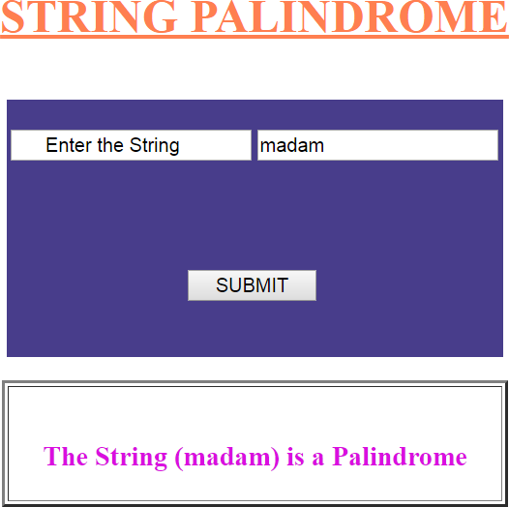

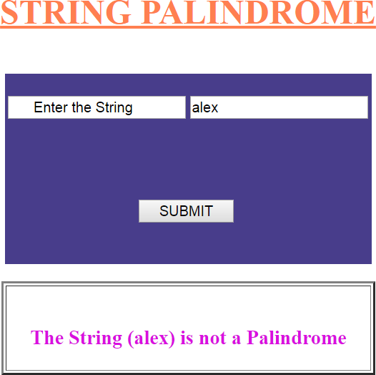

# RECURSIVE FUNCTION

### AIM:

To write a program for display factorial value using Recursive Function

### PROGRAM:

**HTML FILENAME: Fact.html**

<html>

<body bgcolor="darkkhaki">

<form action="factorial.php" method="post">

<center><br><br><br><br><br><br>

<table align="center" border="2" width="30%">

<tr align="center" bgcolor="darkblue"><td><font color="white"><br><h1>FACTORIAL</h1></td></tr>

<tr bgcolor="chocolate"><td><br><br><br>&nbsp;&nbsp;&nbsp;&nbsp;

<font face="arial" size="6" color="white">Enter the Digit:</font>

<input type="text" name="n" size="15">

<br><br><br>&nbsp;&nbsp;&nbsp;&nbsp;&nbsp;&nbsp;&nbsp;&nbsp;&nbsp;&nbsp;&nbsp;&nbsp;&n bsp;&nbsp;&nbsp;&nbsp;

&nbsp;&nbsp;&nbsp;&nbsp;&nbsp;&nbsp;&nbsp;&nbsp;&nbsp;&nbsp;&nbsp;&nbsp;&nbsp;&nbsp;&n bsp;&nbsp;

<input type="submit" value="&nbsp;&nbsp;&nbsp; SEND &nbsp;&nbsp;&nbsp; "><br><br><br>

</td></tr></table>

</center>

</form>

</html>

### PHP FILENAME: Factorial.php

<?php

$m=$_POST["n"]; function factorial($m)

{

if($m<2) return 1; else

return($m*factorial($m-1));

}

$f=factorial($m);

echo'<br><table border="2" align="center"><tr><td>';

echo'<center><font face="arial" size="15" color="crimson">FACTORIAL</font><br><br>'; echo"<b> </b>";

echo'<font face="arial" size="10"><br>'; echo"Given Digit = $m <br>"; echo'<br><font color="green">';

echo "Factorial &nbsp;&nbsp;= $f"; echo"</center></font>"; echo'</td></tr></table>';

?>

**OUTPUT**

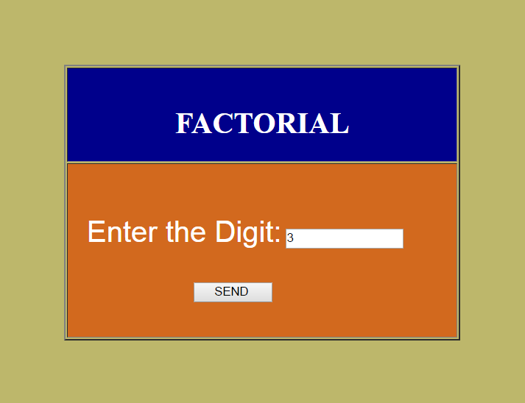

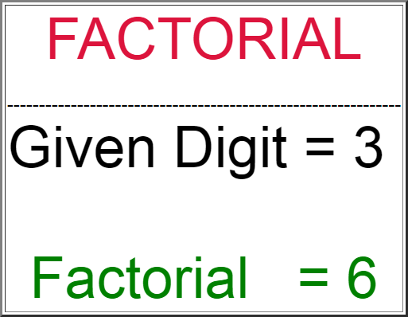

# LOGIN - WITHOUT SQL CONNECTION

### AIM:

To create a php page for login without using SQL connection.

### PROGRAM:

**HTML FILENAME: Log.html**

<html>

<body>

<form action="login.php" method="post">

<table border="0" bgcolor="green" align="center" height="40%" width="30%"><br>

<tr align="center" bgcolor="floralwhite"><td colspan="2"><h2>LOGIN PAGE</h2></td></tr>

<tr align="center"><td><input type="text" size="9" value=" User Name" readonly></td>

<td><input type="text" name="u"></td></tr>

<tr align="center"><td><input type="text" size="9" value=" Password" readonly></td>

<td><input type="password" name="p"></td></tr></table>

<table bgcolor="orange" align="center" height="20%" width="40%">

<tr align="center"><td><input type="submit" value="SUBMIT"></td>

<td><input type="reset" value="CLEAR"></td></tr>

</table>

</body>

</html>

### PHP FILENAME: Login.php

<?php if($_POST)

{

$un=$_POST['u'];

$pw=$_POST['p'];

if($un=="vaidoo" && $pw=="riya")

{

echo'<table align="center" border="2"><tr><td>'; echo'<center><h1>** PERSONAL DETAILS **</h1></center>'; echo'<font color="blue">';

echo'<pre><h3>

NAME - <b><font face="Courier">Riya</font>

D.O.B - <b><font face="Courier">Sep 10,1995</font> BLOOD GROUP - <b><font face="Courier">A+</font> ADDRESS - <b><font face="Courier">Kenikarai</font> CONTACT NO - <b><font face="Courier">04567-220023</font>

EMAIL ID - <b><font face="Courier"[>r](mailto:riya.msc@gmail.com)i[ya.msc@gmail.com](mailto:riya.msc@gmail.com)</font>'; echo'</font></pre></h3></td></tr></table>';

}

else

{

echo'<font face="arial" size="50" color="red">'; echo"<center><br>Invalid<br>USERNAME<br>or <br>PASSWORD<br>!!!!</center>";

}

}

?>

**OUTPUT**

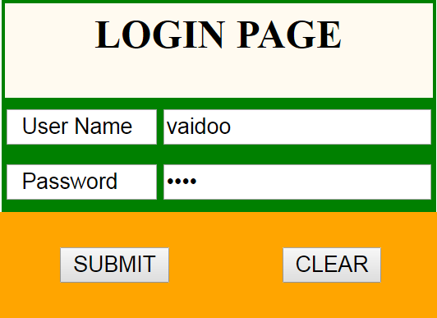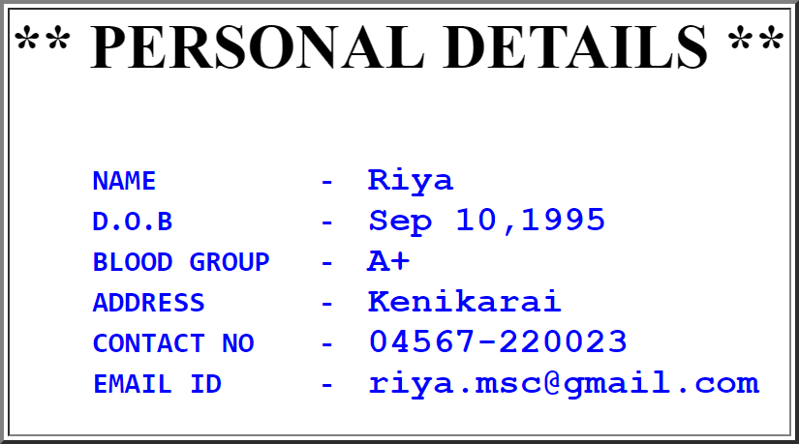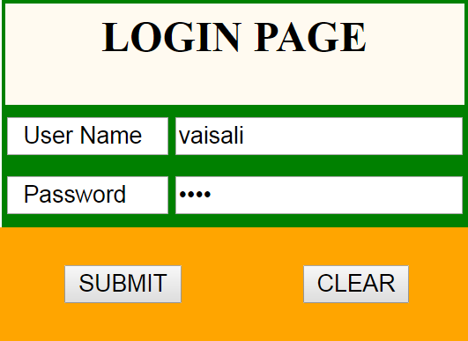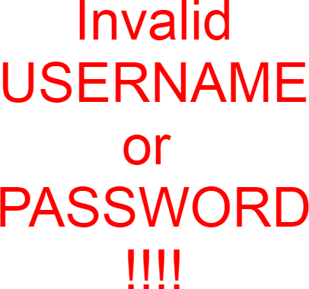

# ARRAY MANIPULATION

### AIM:

To write a php program to manipulate arrays.

### PROGRAM:

<html>

<body bgcolor="megenta">

<?php

$a=Array("crypt","php","dm");

$b=Array("mm","wap","php");

echo'<table align="center" bgcolor="white" border="2"><tr><td>'; echo'<h1 align="center"><u>Array Manipulation</u></h1>'; echo'<b><u>Given Array:</u><br> &nbsp; a=';

print_r($a);

echo'<br> &nbsp; b='; print_r($b);

echo'</b><br><h3><font color="darkbrown">Array Ascending a()&nbsp;&nbsp;:</font></h3>'; sort($a);

print_r($a);

echo'<br><h3><font color="fuchsia">Array Decending a()&nbsp;&nbsp;:</font></h3>'; rsort($a);

print_r($a);

echo'<br><h3><font color="navy">Intersection of a(),b()&nbsp;:</font></h3>'; print_r(Array_intersect($a,$b));

echo'<br><h3><font color="darkred">Difference of a() & b():</font></h3>'; print_r(Array_diff($a,$b));

echo'<h3><font color="darkorange">Merging of a() & b()&nbsp;&nbsp;&nbsp;:</font></h3>'; print_r(Array_merge($a,$b));

echo'<br><h3><font color="darkgreen">Array Slicing in a() &nbsp;&nbsp;&nbsp;&nbsp;:</font></h3>';

print_r(Array_slice($a,2));

echo'<br><h3><font color="dodgerblue">Array Splicing in a() &nbsp;&nbsp;:</font></h3>'; print_r(Array_splice($a,2));

echo'<br><h3><font color="chocolate">Array Poping from a():</font></h3>'; echo'<b>Before :</b>';

print_r($a); Array_pop($a);

echo'<br><b>After &nbsp; :</b>'; print_r($a);

echo'<br><h3><font color="lime">Array Pushing into b():</font></h3>'; echo'<b>Before :</b>';

print_r($b); Array_push($b,"50","30"); echo'<br><b>After &nbsp; :</b>'; print_r($b);

echo'<br><h3><font color="gold">Addition of b() Element:</font></h3>Sum=';

$i=Array_sum($b); print_r($i); echo"</td></tr></table>";

?>

</body></html>

**OUTPUT**

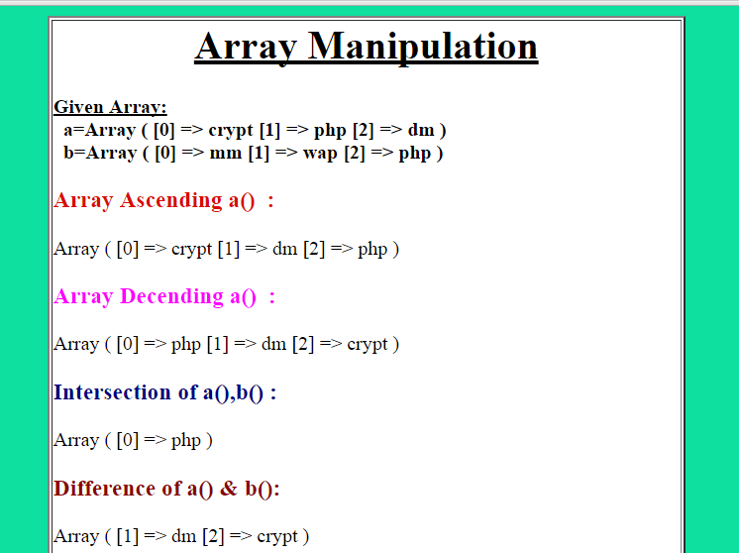

# PERSONAL DETAILS

### AIM:

To write a program for display our personal information using various tags.

### PROGRAM:

<html>

<body text="red" bgcolor="orange"><table align="center" bgcolor="white"><tr><td>

<center><h1><hr><hr>** PERSONAL DETAILS **<hr><hr></h1></center>

<font color="blue"><pre><h3> NAME - <b><font face="Courier">Riya</font>

D.O.B - <b><font face="Courier">Sep 10,1995</font> BLOOD GROUP - <b><font face="Courier">A+</font> ADDRESS - <b><font face="Courier">Kenikarai</font> CONTACT NO - <b><font face="Courier">04567-220023</font>

EMAIL ID - <b><font face="Courier"[>r](mailto:riya.msc@gmail.com)i[ya.msc@gmail.com](mailto:riya.msc@gmail.com)</font></font>

<font color="deeppink"><center><hr><hr><h1> ** MY FAVOURITES **</h1></center>

<hr><hr><font color="green"> FRIEND : <b><font face="Courier"> Akila</font> FOOD : <b><font face="Courier"> Idly</font>

COLOUR : <b><font face="Courier">Blue & Pink</font> PLACE : <b><font face="Courier">USA</font> SPORTS : <b><font face="Courier"> Football</font>

DIRECTOR : <b><font face="Courier">Gowtham vasudev menan</font>

BOOK : <b><font face="Courier">The MONK Who Sold His FERRARI</font> MOVIE : <b><font face="Courier">Ok Ok</font>

HOBBIES : <b><font face="Courier">Drawing </font>

</font></pre></h3></td></tr></table>

</body></html>

**OUTPUT**

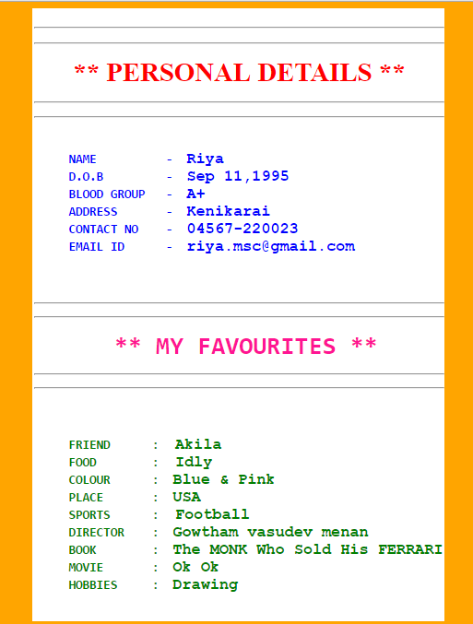

# LOGIN WITH SQL CONNECTION

### AIM:

To create a php program for login page with SQL connection.

### PROGRAM:

**HTML FILENAME: Db.html**

<html>

<body>

<form action="sql.php" method="post">

<br><center><table border=2" bordercolor="red">

<tr><td><table><tr font face="white">

<th colspan="2" bgcolor="crimson" align="center">

<h3>LOGIN FORM</th></tr>

<tr><th align="left">UserName</th>

<td><input type="text" name="u"></td></tr>

<tr><th align="left">Password</th>

<td><input type="password" name="p"></td></tr>

<tr align="center"><br><td><input type="submit" value=" LOGIN "></td>

<td><input type="reset" value=" CLEAR "></td></tr>

</table></td></tr></table>

</center></form></body></html>

### PHP FILENAME: Sql.php

<?php_track_vars ?>

<?php

$un=$_POST['u'];

$pd=$_POST['p'];

$con=0;

$db=mysql_connect("localhost","root","");

$sel=mysql_select_db("vaidoo",$db);

$res=mysql_query("SELECT name,password FROM riya"); while($row=mysql_fetch_array($res))

{

if($un==$row{"name"} && $pd==$row{"password"})

{

$con=1;

}

}

if($con==1)

{

echo"<font color='blue' size='5' align='center'>Welcome to this pc</font>";

}

else

{

echo"<font color='red' size='5' align='center'>Invalid Username or Password</font>";

}

mysql_close($db);

?>

Ouput:

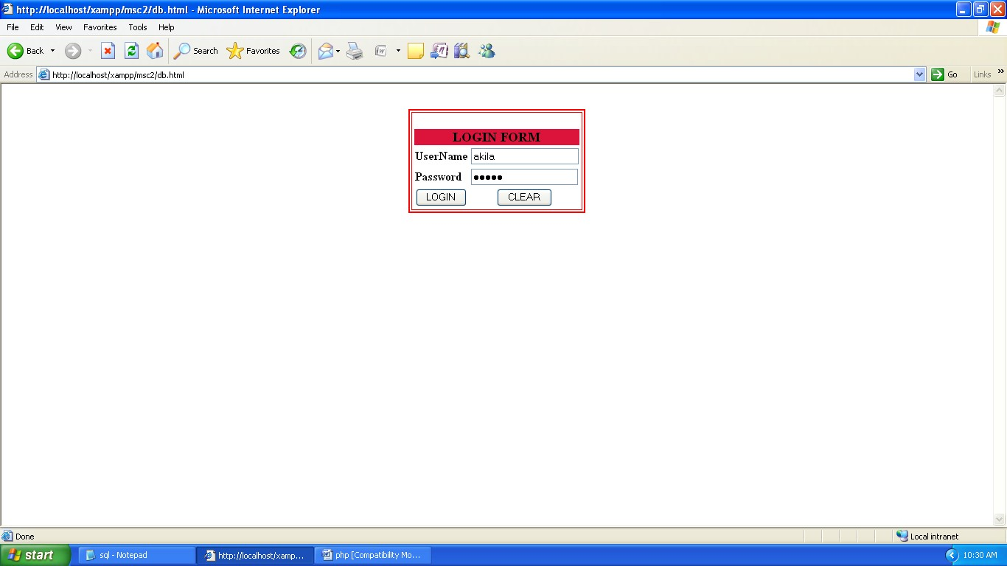

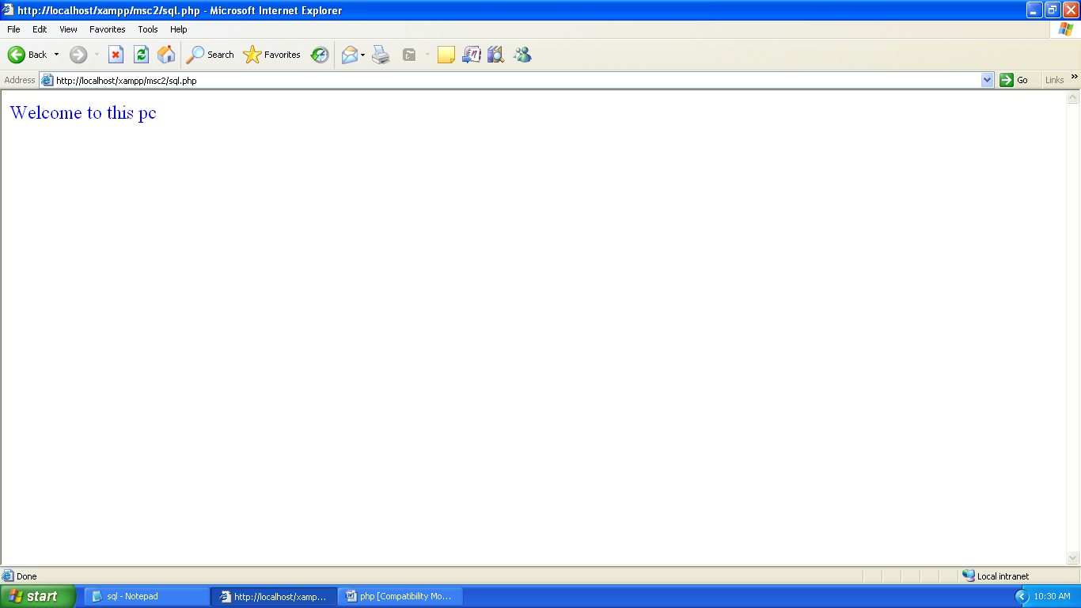

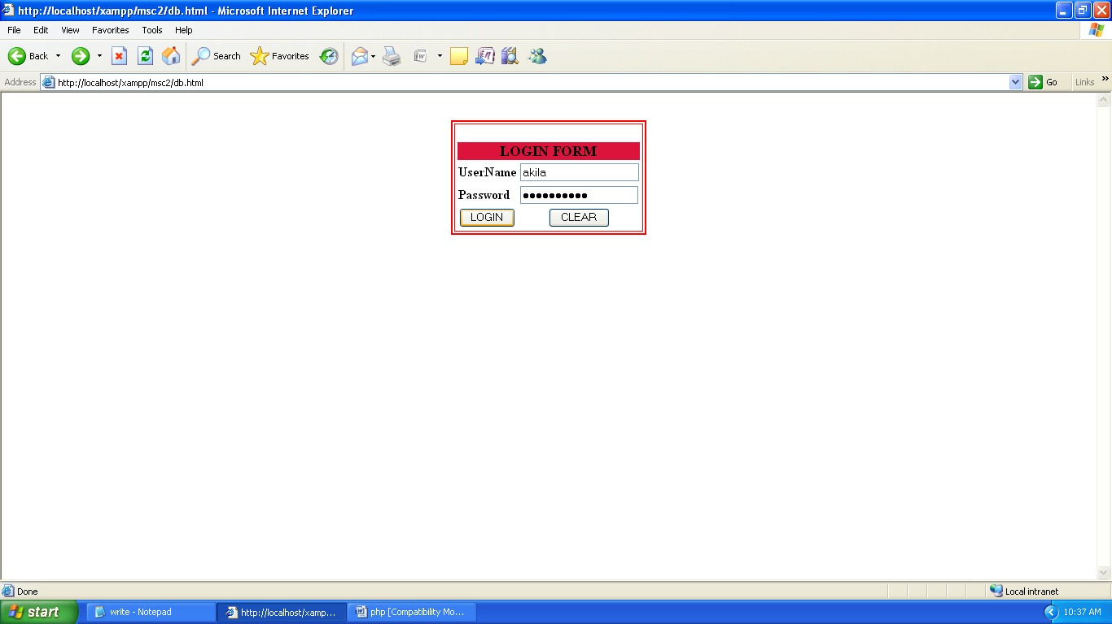

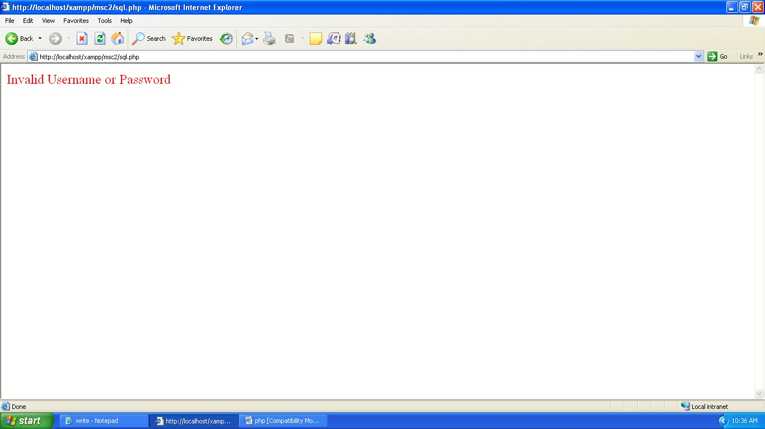

# READ FROM EXISTING FILE

### PROGRAM:

<html>

<body>

<form method="post">

<table align="center">

<font color="deeppink"><h1><u>READ THE FILE</u></h1></font>

<tr><td><b>Enter Your File Name&nbsp;:</b></td><td><input type="text" name="file"></td></tr><br>

<tr><td><b>Choose File Extension :</b></td><br>

<td><select name="ext">

<option>.txt</option>

<option>.doc</option>

<option>.pdf</option>

</select></td></tr><br>

<tr><td><b>Content Of The File:</b></td><td><textarea rows="10" cols="16" name="data">

<?php echo @$contents;?></textarea></td></tr>

<tr colspan=2 align="center"><td>&nbsp;&nbsp;&nbsp;&nbsp;&nbsp;&nbsp;&nbsp; &nbsp;&nbsp;&nbsp;&nbsp;&nbsp;&nbsp;&nbsp;&nbsp;&nbsp;&nbsp;&nbsp;&nbsp;

<input type="submit" value="DISPLAY" name="disp">

</td></tr></table></form></body></html>

<?php if(isset($_POST['disp']))

{

$f=$_POST['file'];

$ext=$_POST['ext'];

$data=$_POST['data'];

$file=$f.$ext; if(file_exists($file))

{

$fo=fopen($file,"r");

$contents=fread($fo,filesize($file));

}

else

{

echo'<font color="deeppink" face="arial black"><center>File Not Exits</center></font>';

}

}

?>

Ouput:

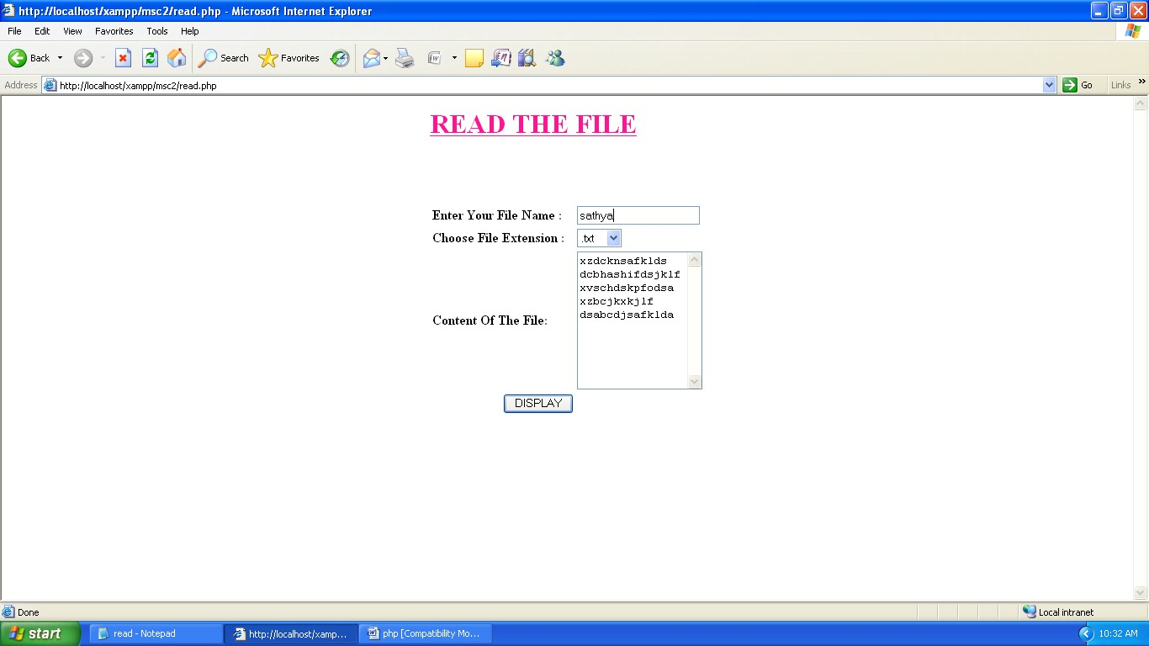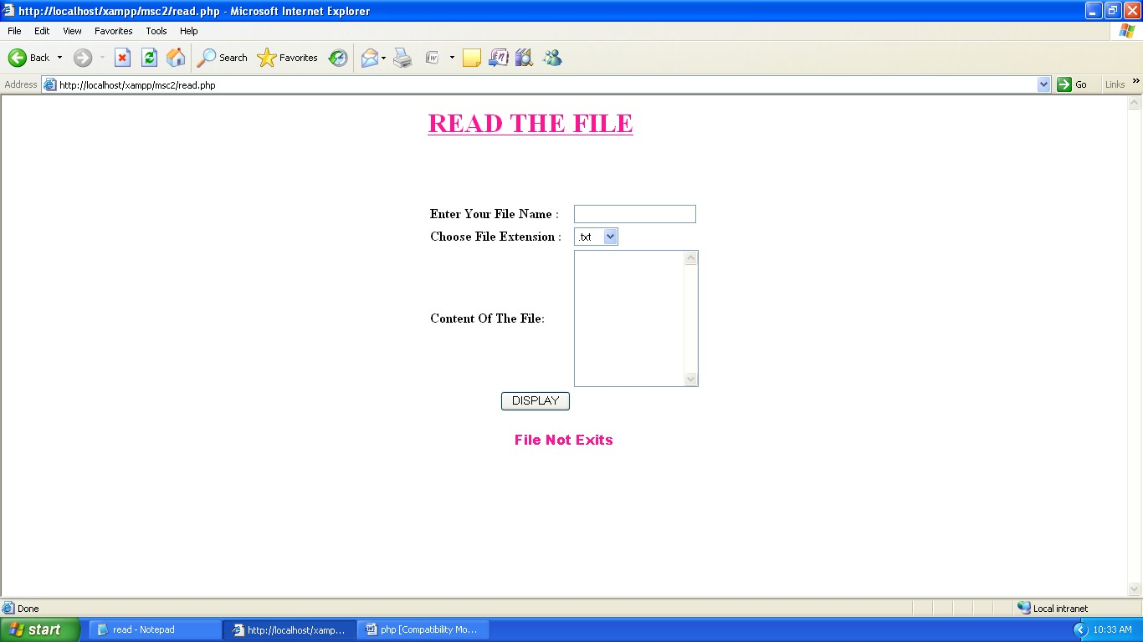

# WRITE A NEW FILE

### PROGRAM:

<html>

<body>

<form method="post">

<table align="center">

<font color="deeppink"><h1><u>WRITE THE FILE</u></h1></font>

<tr><td><b>Enter Your File Name :</b></td><td><input type="text" name="file"></td></tr><br>

<tr><td><b>Choose File Extension :</b></td>

<td><select name="ext">

<option>.txt</option>

<option>.doc</option>

<option>.pdf</option>

</select></td></tr><br>

<tr><td><b>Write Content of File :</b></td><td><textarea rows="10" cols="16" name="data">

<?php echo @$contents;?></textarea></td><br>

<tr colspan="2" align="center"><td><input type="submit" value=" SAVE " name="disp">

</td></tr></table></form></body></html>

<?php

$f=$_POST['file'];

$ext=$_POST['ext'];

$data=$_POST['data'];

$file=$f.$ext; if(file_exists($file))

{

echo'<font color="green" face="arial black"><center>Your File Already Exists</center></font>';

}

else

{

$fo=fopen($file,"w"); fwrite($fo,$data);

echo'<font color="deeppink" face="arial black"><center>Your Data is Saved</center></font>';

}

?>

**OUTPUT**

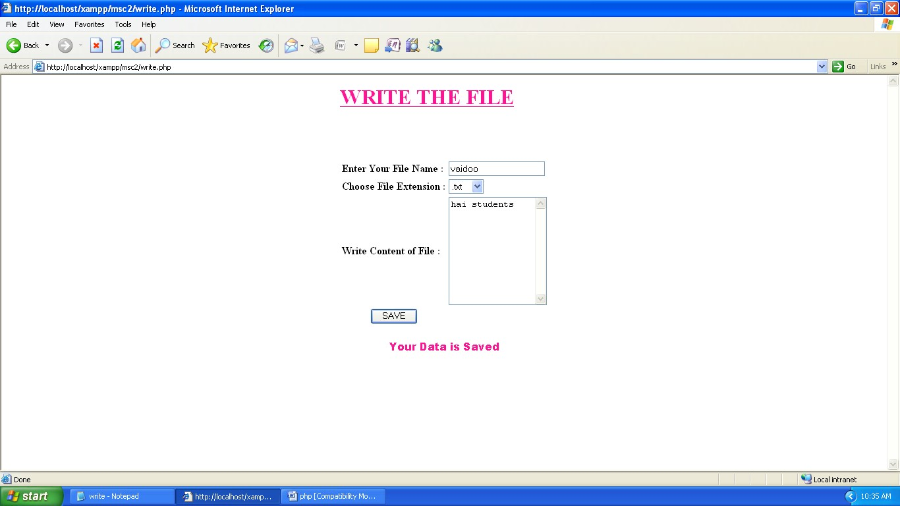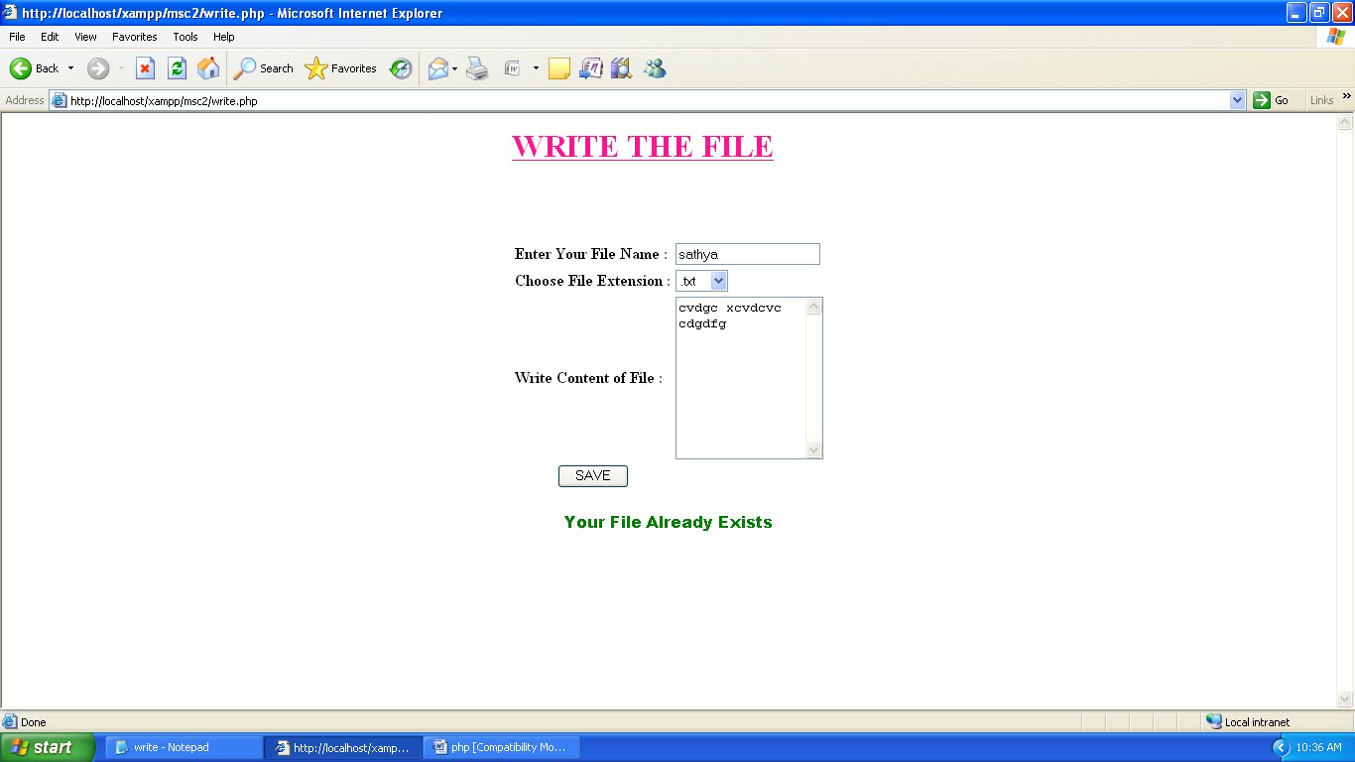

# DATE & TIME FUNCTION

### AIM:

To write a program for display the date and time.

### PROGRAM:

<html>

<body bgcolor="green">

<?php

echo'<table align="center" bgcolor="white"><tr><td>';

echo'<h1><u><font color="crimson" face="cooper black">Date & Time Function</font></u></h1><br>';

echo'<b>Current Date, i.e. 16-12-31</b><br>'; echo date("y-m-d");

echo'<br><br><b>Current Month, i.e. 08 </b><br>'; echo date("m");

echo'<br><br><b>Current Month Name, i.e. Jan </b><br>'; echo date("M");

echo'<br><br><b>Current Timestamp</b><br>'; echo time();

$d=strtotime("tomorrow"); echo'<br><br><b>Tomorrow Date is</b><br>'; echo date("y-m-d h:i:sa",$d);

$d=strtotime("Next Saturday"); echo'<br><br><b>Next Saturday is</b><br>'; echo date("y-m-d h:i:sa",$d);

$d=strtotime("+3 months"); echo'<br><br><b>After 3 Month</b><br>'; echo date("y-m-d h:i:sa",$d);

$d=mktime(11,14,54,18,12,2014);

echo"<br><br><b>Created Date is</b><br>".date("y-m-d h:i:sa",$d); echo'<br><br><b>Increase 1 day From Current Date </b><br>'; echo"Date is".date("y-m-d",time()+86400); echo'<br><br><b>Decrease 15 days From Current Date </b><br>'; echo"Date is".date("y-m-d",time()-(86400*15));

echo'<br><br><b>Current Time in 12hr Format,i.e. 08:50:55pm</b><br>'; echo date("h:i:sa");

echo'<br><br><b>Current Time in 24hr Format,i.e. 18:50:55pm</b><br>'; echo date("H:i:s");

echo'</td></tr></table>';

?>

</body>

</html>

**OUTPUT**

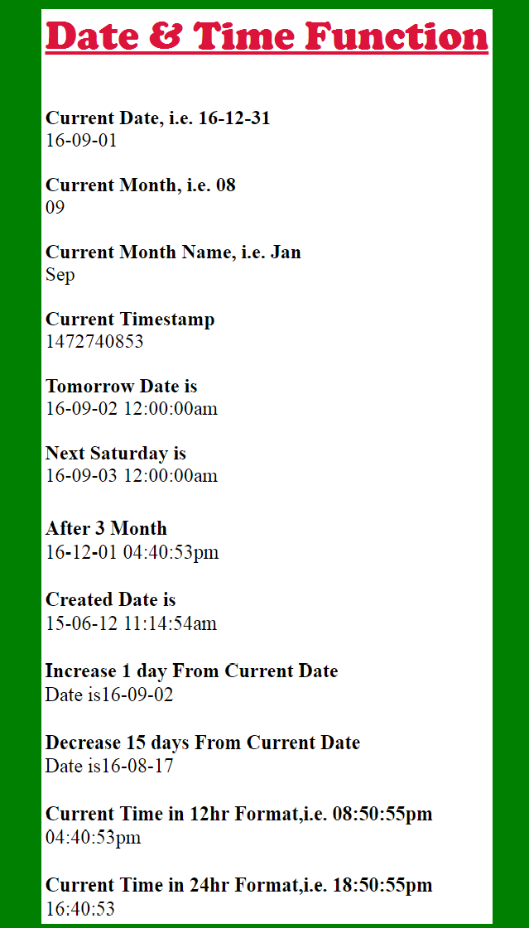

# CURRICULUM VITAE

### AIM:

To write a program for displaying our curriculum vitae.

### PROGRAM:

<html>

<title>Resume</title>

<body>

<pre><font face="arial black">VAIDOORIYA. M, [vaidoo.msc@gmail.com](mailto:vaidoo.msc@gmail.com)

Kenikarai, 9999 999 999

Ramanathapuram.</font></pre><hr>

<h2><u><font color="orange">JOB OBJECTIVE:</font></u></h2>

<p>A website developer position where advanced creative skills will produce a quality website for the company.</p>

<h2><u><font color="orange">ACADEMIC PROFILE:</font></u><br></h2>

<h4><font color="green">POST GRADUATION:</font></h4>

<pre>

<b>Course</b> : M.Sc(Computer Science)

<b>University</b> : Alagappa University

<b>College</b> : Government Arts College for Women,Ramanathapuram.

<b>Year of Passing</b> : 2015-2017

<b>Percentage</b> : Pursuing</pre>

<h4><font color="green">UNDER GRADUATION:</font></h4>

<pre>

<b>Course</b> : B.Sc(Computer Science)

<b>University</b> : Alagappa University

<b>College</b> : Syed Ammal Arts & Science College,Ramanathapuram.

<b>Year of Passing</b> : 2012-2015

<b>Percentage</b> : 76%</pre>

<h4><font color="green">HIGHER SECONDARY:</font></h4>

<pre>

<b>School</b> : D.D.Vinayagar Hr.Sec. School

<b>Board</b> : State Board

<b>Year of Passing</b> : 2010-2012

<b>Percentage</b> : 82%</pre>

<h3><font color="green">SSLC:</font></h3>

<pre>

<b>School</b> : Raja Dhinagar R.C High School

<b>Board</b> : State Board

<b>Year of Passing</b> : 2009-2010

<b>Percentage</b> : 88.4%</pre>

<h2><u><font color="orange">ACHIEVEMENTS:</font></u></h2>

<ul>

<li>Certificate of Merit in SHIBUKAN SHITO - RYU KARATE -DO, <b>District Open Championship</b> -2010.

<li><b>First prize</b> on Rotary Club <b>Fashion Show, District Level</b> -2012.

<li><b>First prize</b> on Intercollegiate Met Excel College for <b>Fashion Show, National Level</b> - 2013.</ul>

<h2><u><font color="orange">ADDITIONAL QUALITFICATION:</font></u></h2>

<ul>

<li>Certificate of Proficiency in <b>PEC</b>, Binx Computer Education.

<li>Type writing <b>Senior</b> Grade <b>First Class</b> in English</ul>

<h2><u><font color="orange">DECLARATION:</font></u></h2>

<p>I hereby declare that the details provided above are true to the best of my knowledge.</p><br><br>

<pre>

<b>Place:</b> Ramanathapuram <b>Yours faithfully,</b>

<b>Date :</b> 22.7.16 <font face="Brush Script MT">(M. Vaidooriya)</font>

</body></html>

**OUTPUT**



# HIT COUNTER USING COOKIES

### AIM:

To write a PHP program for counting the visiting page using cookie.

### PROGRAM:

<?php

if (!isset($_COOKIE['visits'])) $_COOKIE['visits'] = 0;

$visits = $_COOKIE['visits'] + 1; setcookie('visits',$visits,time()+3600*24*365);

?>

<html>

<head><style type="text/css">

div {font-size:20pt;color:navy;font-family:arial black; width:50%;background-color:white} p{font-size:18pt;color:lime;font-weight:bold;text-align:center;font-family:bauhus 93}

.groove{border-style:groove}

.dotted{border-style:dotted}

</style></head><body bgcolor="salmon">

<?php

echo'<br><br><center><div class="groove">HIT COUNTER USING COOKIES</div><br>'; echo'<div class="dotted">';

if ($visits > 1) {

echo "<p>This is visit number $visits</p>";} else {

echo'<p>Welcome to my Website! Click here for a tour!</p>';

}echo"<br></center></div>";

?></body></html>

**OUTPUT**

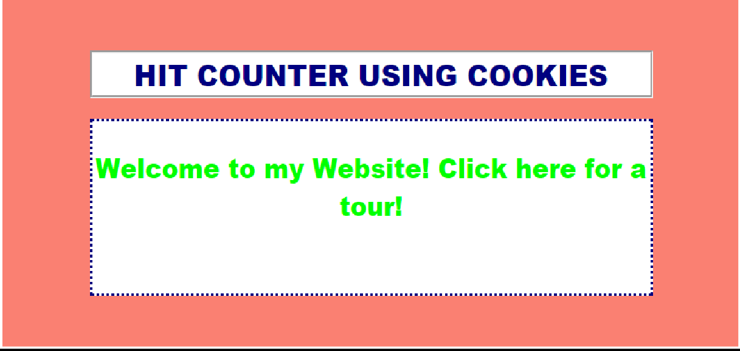

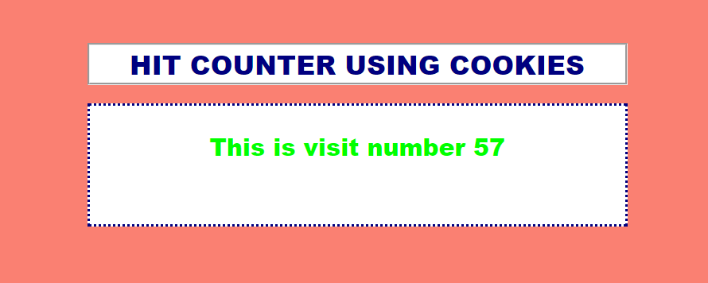

**PRODUCT ADVERTISEMENT WITH AUDIO**

**PRODUCT.PHP**

<html>

<body background="wall.jpg">

<bgsound src="Kalimba.mp3">

<?php echo"

<p><b><font size=6 color='red' >MARUTHI SUZUKI</b></font></p>

<p align=right><font size=5 color=white><i>NEXA<br></i></b></font></p>

<align='right'><img src='imah.png' width='20% hright='20%'>

<table align=center cellpadding=5 cellspacing=9><tr><td>

<p><font size=8 color='white'>Live</font><font size=6>the</p> </td></tr>

<tr><td>

<p><font size=8 color=white>CROSSOVER</font><font size=6>life</td>

<td><font size=4 color=aqua>The city or the wild, the smooth tracks or the dusty trails,<br> S-Cross can take you wherever your destination lies. <br>

It's made to match your crossover life,<br> and give you a drive truly above the ordinary.

</td></tr></table>

<center><img src='cars.jpg' width='80%' height='400'></center><hr>

<p><font color='white' size=5><b>ABOVE THE ORDINARY FEATURES</b></p>

<table><tr>

<td><p><font color='white' size=5>SmartPlay Infotainment<br>System 18 cm(7)</p><img src='111.jpg' width='75%' height='75%'></td>

<td><p><font color='white' size=5>Excellent <br>Cruise Control</p><img src='112.jpg' width='75%' height='75%'></td>

<td><p><font color='white' size=5>Steering Mounted Audio & <br>Voice controls</p><img src='115.jpg' width='75%' height='75%'></td>

<td><p><font color='white' size=5>Auto Rain sensing<br> wipers</p><img src='114.jpg' width='115%' height='75%'></td>

<td><p><font size=6 color='red'>&nbsp;&nbsp;&nbsp;&nbsp;&nbsp;&nbsp;&nbsp;&nbsp;S-CROSS

</font><br><font size=5>&nbsp;&nbsp;&nbsp;&nbsp;&nbsp;&nbsp;&nbsp;&nbsp;&nbsp;&nbsp;The Premium<br>&nbsp;&nbsp;&nbsp;&nbsp;&nbsp;&nbsp;&nbsp;&nbsp;&nbsp;&nbsp; Crossover</font></td></tr></table><hr>

<p align='center'><font color='red' size=5>MADURAI</p></font>

<h2 align='center'><font color='orange'>NEXA K K NAGAR: <b>ASIR AUTOMOBILES:80125 51220</b></h2><hr>

";

?>

</body>

</html>

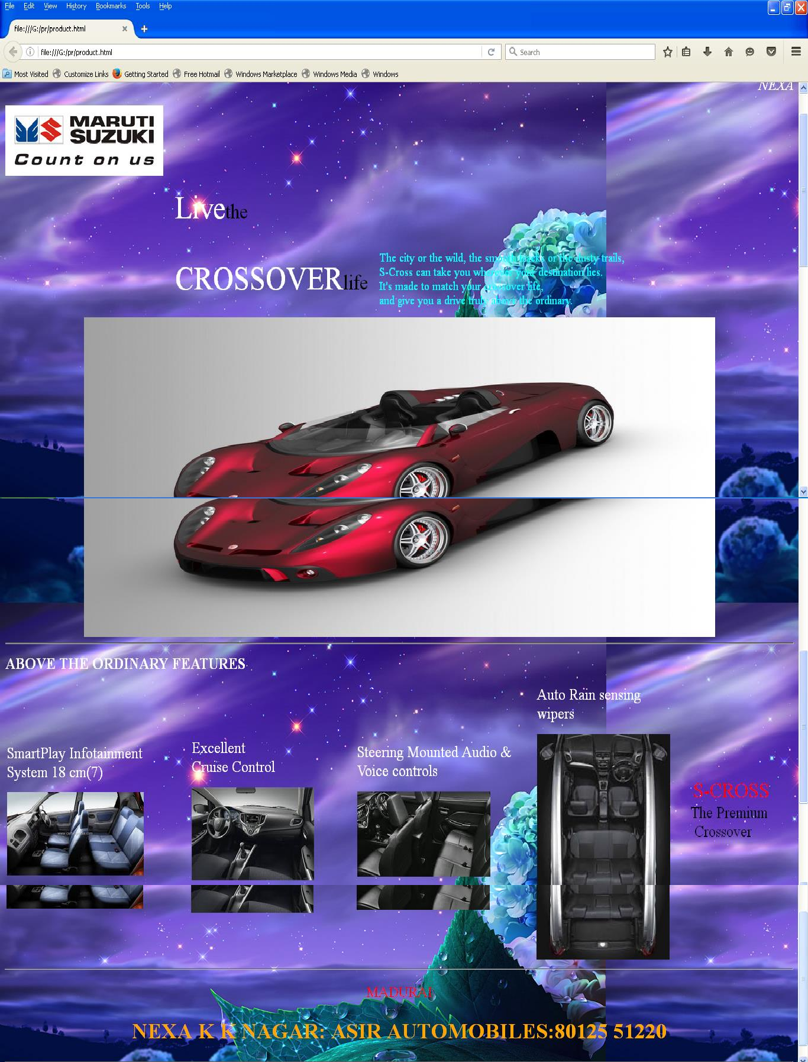

## HIT COUNTER USING COOKIES

**COOKIES.PHP**

<?php

setcookie('count', isset($_COOKIE['count']) ? $_COOKIE['count']++ : 1);

$visitCount = $_COOKIE['count'];

?>

<html>

<head>

<title>Count Page Access</title>

</head>

<body>

<?if ($visitCount == 1): ?>

Welcome! This is the first time you have viewed this page.

<?else:?>

You have viewed this page <?= $_COOKIE['count'] ?> times.

<?endif;?>

</body>

</html>

OUTPUT SCREEN

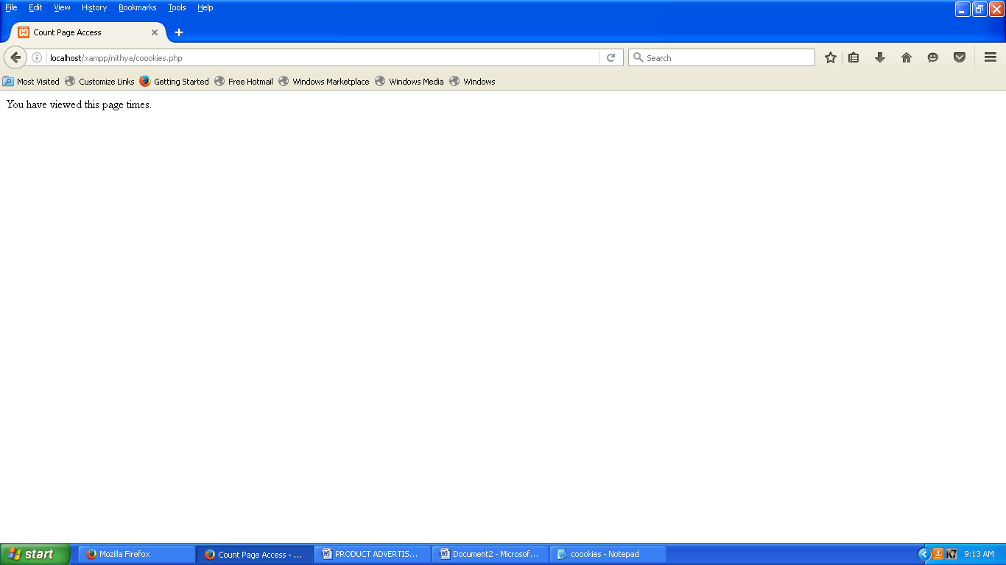

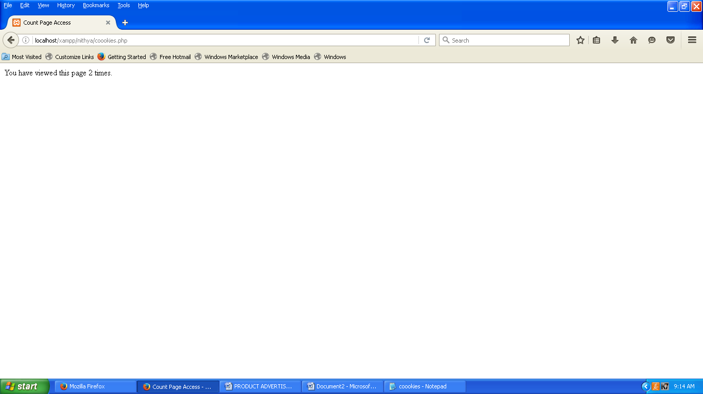

LOGIN PAGE USING SESSION

**LOGOUT.PHP**

<?php header('location:des.php');

?>

**DES.PHP**

<?php session_start();

if(@$_POST['submit1'])

{

$u = $_POST['text1'];

$p = $_POST['pwd'];

if($u =="[nithyasuhana@gmail.com](mailto:nithyasuhana@gmail.com)" && $p=="nithya@1986")

{

$_SESSION['luser'] = $u;

$_SESSION['start'] = time();

// taking now logged in time

$_SESSION['expire'] = $_SESSION['start'] + (1*60) ;

// ending a session in 1 minutes from the starting time header('Location: home.php');

}

else

{

$err= "<font color='red'>Invalid user login </font>";

}

}

?>

<html>

<head>

<title>Destroy Session after 1 minutes - Phptpoint.com</title>

</head>

<body>

<form name="form1" method="post">

<table align="center">

<tr>

<Td colspan="2"><?php echo @$err;?></Td>

</tr>

<tr>

<td>Username </td>

<td><input type="email" name="text1" placeholder="[nithyasuhana@gmail.com](mailto:nithyasuhana@gmail.com)"

required>

</td>

</tr>

<tr>

<td>Password</td>

<td><input type="password" name="pwd" placeholder="nithya@1986" required></td>

</tr>

<tr>

<td colspan="2" align="center">

<input type="submit" value="SignIn" name="submit1">

</td> </tr>

</table>

</form>

</body>

</html>

**HOME.PHP**

**<?php session_start();**

### if(!isset($_SESSION['luser']))

**{**

### echo "<p align='center'>Please Login again ";

**echo "<a href='des.php'>Click Here to Login</a></p>";**

### }

**else**

### {

**$now = time();**

### // checking the time now when home page starts if($now > $_SESSION['expire'])

**{**

### session_destroy();

**echo "<p align='center'>Your session has expire ! <a href='login.php'>Login Here</a></p>";**

### }

**else**

### {

**?>**

### <html>

**<head>**

### <title>Destroy Session after 1 minutes - Phptpoint.com</title>

**</head>**

### <body>

**<p style="background:#CCCCCC">**

### Welcome <?php echo $_SESSION['luser']; ?>

**<span style="float:right"><a href='logout.php'>LogOut</a></span>**

### <p style="padding-top:20px;background:#CCCCCC; height:400px; text-align:center">

**<span style="color:red;text-align:center">Your Session Will destroy after 1 minutes You will redirected on next page</span>**

### <br/><br/>

**<span>if you want to logout before 1minutes click on logout link </span>**

### </p>

**</p>**

### <?php>}

**?>**

### </body>

**</html>**

## LOGIN PAGE

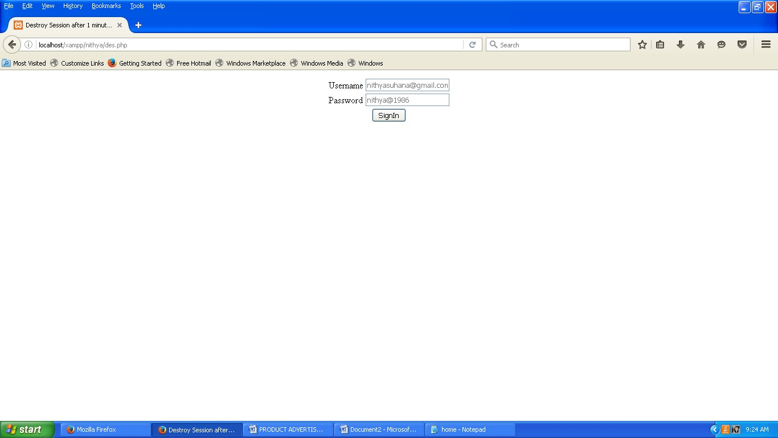

**OPEN HOME PAGE**

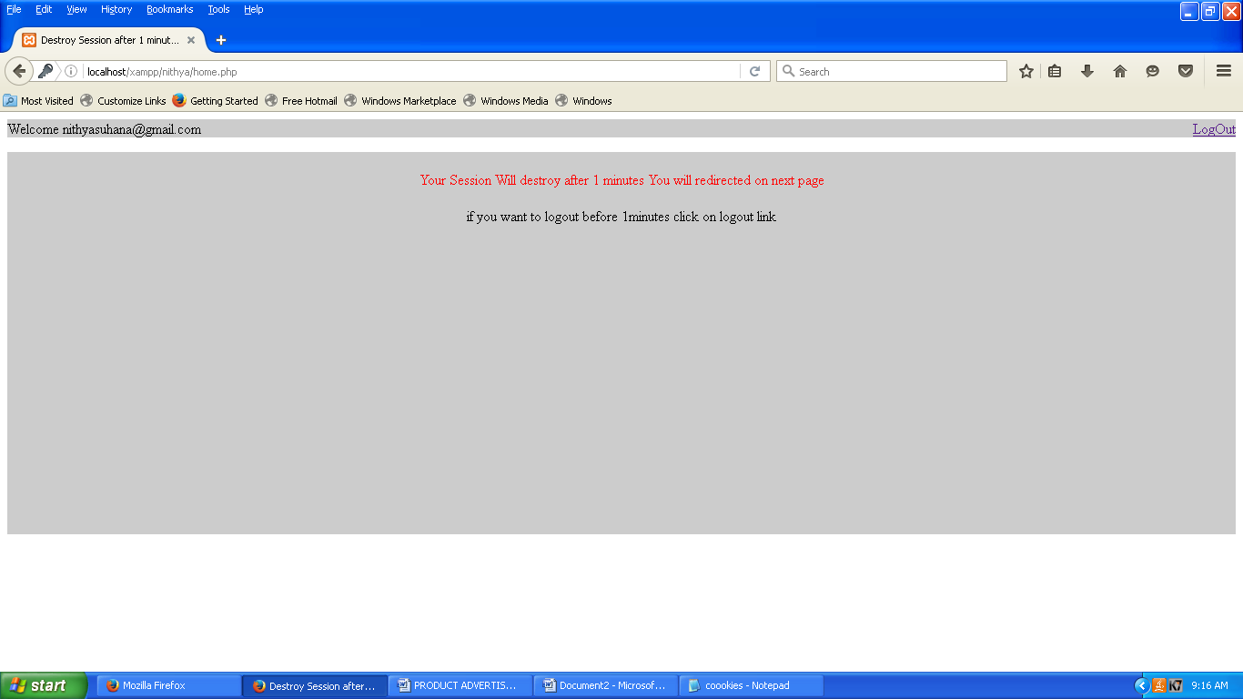

## DESTROY SESSION

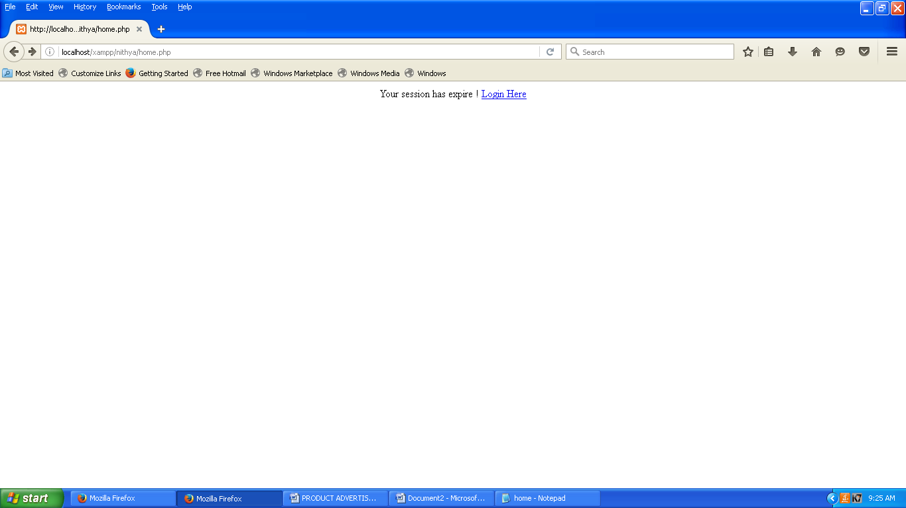

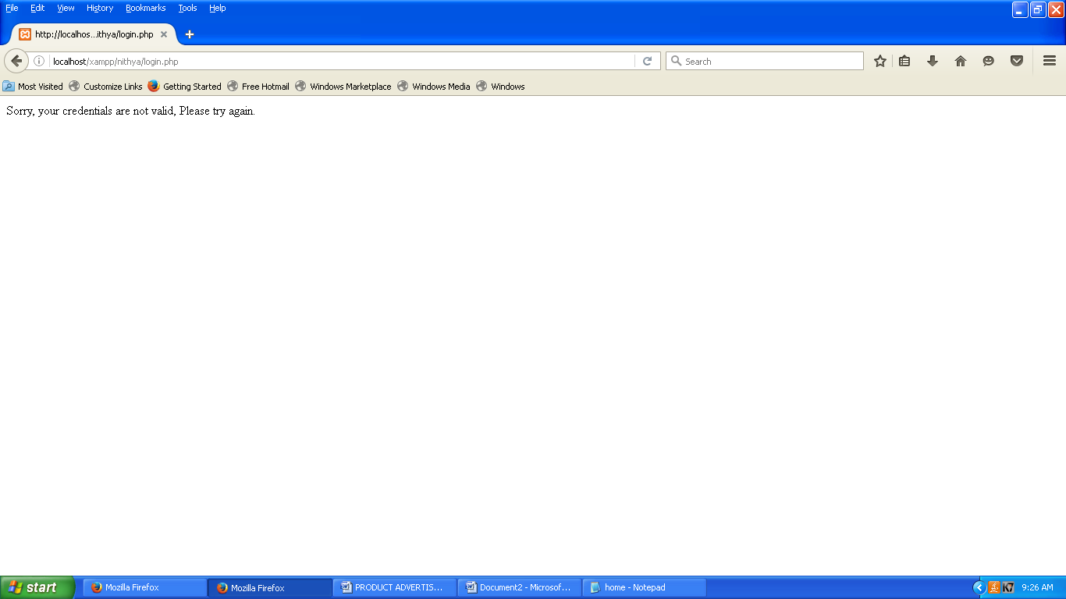

**TRAVEL AGENCY WEBSITE**

### AGENCY.PHP

<html>

<frameset rows="30%,30%" border="0">

<frame src="s11.php" noresize="noresize">

<frameset cols="30%,50%">

<frame src="c12.php" >

<frame src="c13.php" name="content">

</frameset>

</frameset>

</html>

### S11.PHP

<html><tabe>

<tr>

<td>

<img src="images.jpg" alt="HTML5 Icon" style="width300px;height:200px;"></td>

<td>

<img src="images (2).jpg" alt="HTML5 Icon" style="width300px;height:200px;"></td>

<td>

<img src="images (3).jpg" alt="HTML5 Icon" style="width300px;height:200px;"></td>

<td>

<img src="images (4).jpg" alt="HTML5 Icon" style="width300px;height:200px;"></td>

<tr>

<div style="background-color:skyblue;color:white;font-size:20pt;text-align:center">

<pre>

<a href="c13.php" target="content">HOME</a> <a href="c21.php" target="content">DOMESTIC PACKAGE</a> <a href="c3.php" target="content">GALLERY</a> </pre>

</div>

</tr>

</body>

</html>

### C12.PHP

<html>

<bgcolor="black">

<pre>

<tr>

<img src="images.png" alt="HTML5 Icon" style="width1000px;height:200px;">

</tr>

</font>

</pre>

</body>

</html>

### C13.PHP

<html>

<body bgcolor="black">

<font color="yellow" face="Comic Sans MS">

<pre>

Late Haji Janab Allah Baksh was the founder and Chairman of AB Business Enterprises which started his whole journey with a single taxi in the year 1967.[7] The brand Parveen was launched in the year 1980.[8]

The company started its journey as a travel operator and has slowly embarked its presence in logistics, Manpower Consultancy, Fuel, Restaurants, Automobiles, Tourism, Driving academy and Automobile spare parts.[9][10][11][12]

Parveen Launched E-commerce website in 2004.[13][14]

Parveen Travels had a First Mover advantage being the first to introduce online ticketing for intercity service in 2004.[15][16]

In 2010, Parveen Travels became the first owners of the Mercedes-Benz multi-axle buses in India.[17]

On April 27, 2010, Parveen Travels launches bus with facilities to conduct business conferences while traveling in Chennai.[18][19][20]

</pre>

</font>

</body>

</html>

### C13.PHP

**<html>**

### <body bgcolor="black">

**<font color="yellow" face="Comic Sans MS">**

### <pre>

**Late Haji Janab Allah Baksh was the founder and Chairman of AB Business Enterprises which started his whole journey with a single taxi in the year 1967.[7] The brand Parveen was launched in the year 1980.[8]**

### The company started its journey as a travel operator and has slowly embarked its presence in logistics, Manpower Consultancy, Fuel, Restaurants, Automobiles, Tourism, Driving academy and Automobile spare parts.[9][10][11][12]

**Parveen Launched E-commerce website in 2004.[13][14]**

### Parveen Travels had a First Mover advantage being the first to introduce online ticketing for intercity service in 2004.[15][16]

**In 2010, Parveen Travels became the first owners of the Mercedes-Benz multi-axle buses in India.[17]**

### On April 27, 2010, Parveen Travels launches bus with facilities to conduct business conferences while traveling in Chennai.[18][19][20]

**</pre>**

### </font>

**</body>**

### </html>

**C21.PHP**

### <html>

**<table>**

### <tr>

**<img src="allappey2.jpg" alt="HTML5 Icon" style="width300px;height:200px;"></td>**

### </tr>

**<tr>**

### Munnar & Alleppey

**Package - 03 Nights - 04 Days<br>**

### <hr color=black>

**Price per person from $ 192<br>**

### <hr size=4>

**Package Cost Category Standard<br> Category – Standard Pax 1 -3 Pax 4-6 <br> Pax 7-9 Twin sharing More info<br>**

### <input type="button" value="BOOK NOW" color="red">

**</tr>**

### </table>

**</html> C3.PHP**

### <html><tabel>

**<tr>**

### <td>

**<img src="images (5).jpg" alt="HTML5 Icon" style="width300px;height:200px;"></td>**

### <td>

**<img src="images (6).jpg" alt="HTML5 Icon" style="width300px;height:200px;"></td>**

### <td>

**<img src="images (7).jpg" alt="HTML5 Icon" style="width300px;height:200px;"></td>**

### <td>

**<img src="images (8).jpg" alt="HTML5 Icon" style="width300px;height:200px;"></td>**

### <td>

**<img src="images (9).jpg" alt="HTML5 Icon" style="width300px;height:200px;"></td>**

### </tr>

**</table>**

**</html>**

**OUTPUT DESIGN**

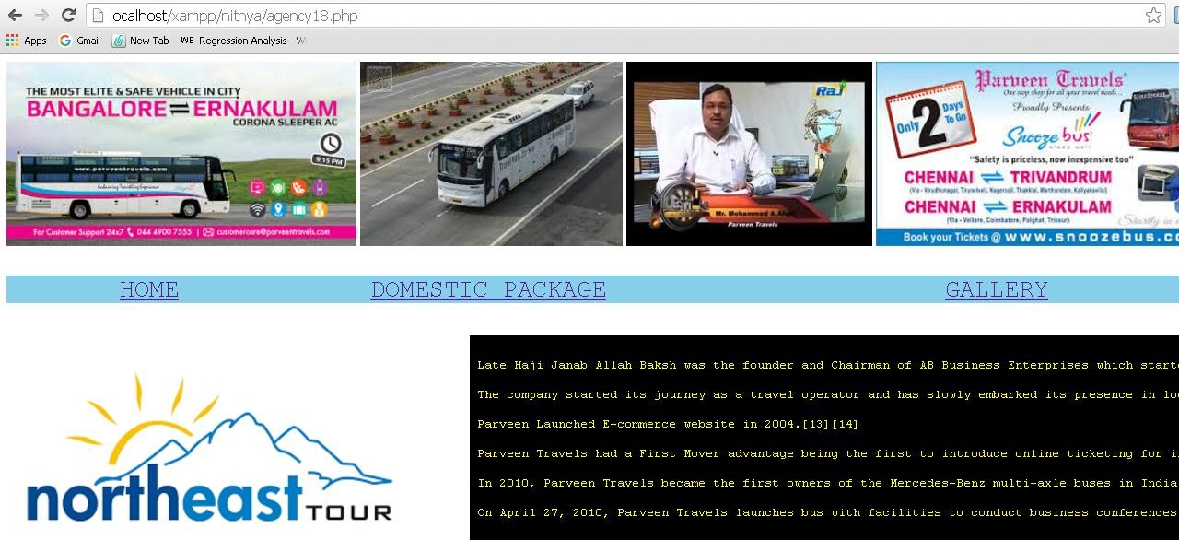

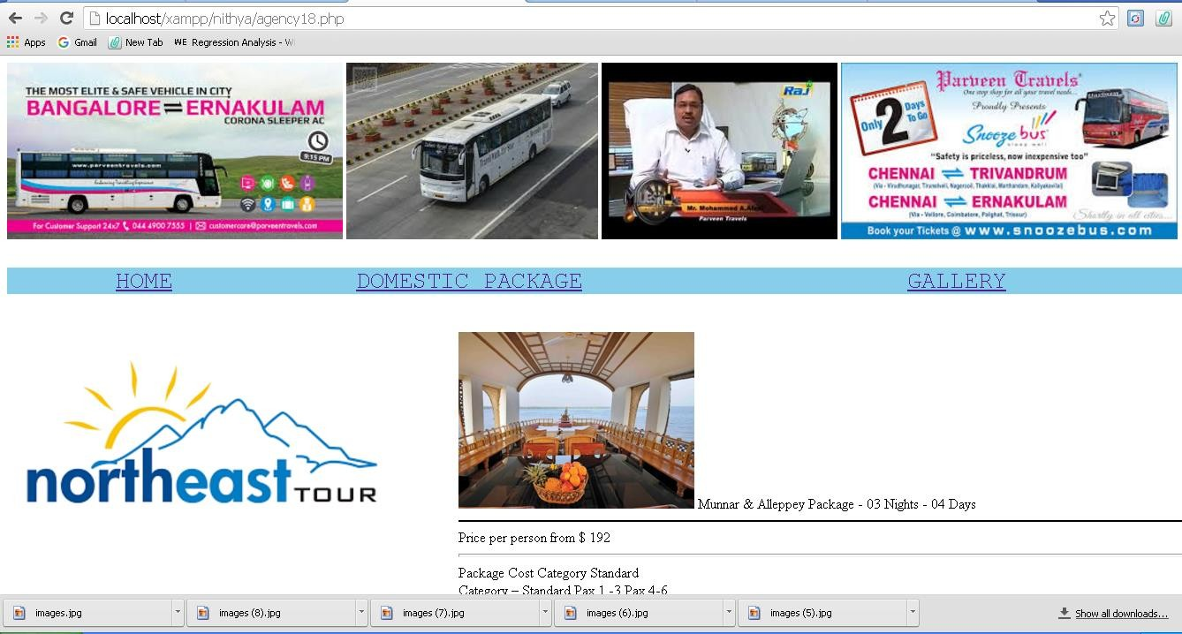

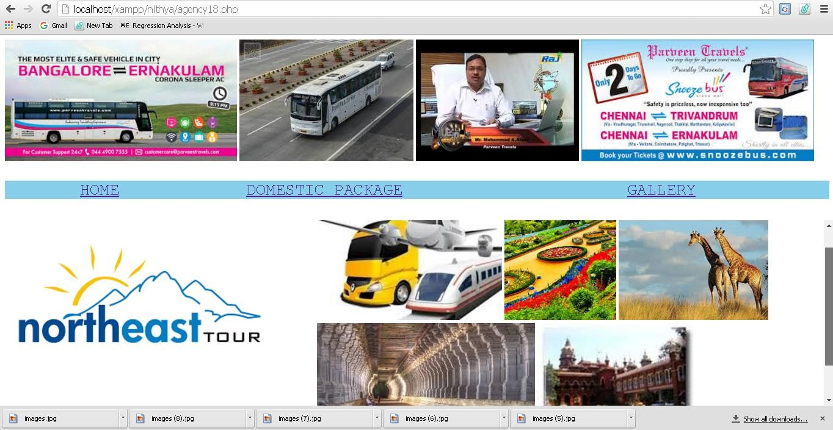

# SOFTWARE COMPANY WEBSITE

### AIM:

To write a PHP program for software company web page using Hyperlink.

### PROGRAM:

**Soft.php**

<html>

<frameset rows="8%,30%,50%,30%" border="0">

<frame src="s1.html" noresize="noresize" scrolling="no" marginwidth="30">

<frame src="s2.html" marginwidth="30" scrolling="no">

<frameset cols="60%,20%">

<frame src="c1.html" name="content" marginwidth="20" scrolling="no">

<frame src="s4.html" noresize marginwidth="27" marginheight="15" border="0" scrolling="no">

</frameset>

<frameset cols="20%,20%,20%">

<frame src="s5.html" scrolling="no" marginwidth="100">

<frame src="s6.html" scrolling="no" marginwidth="100">

<frame src="s7.html" scrolling="no" marginwidth="100">

</frameset>

</html>

**S1.php**

<html>

<body bgcolor="darkblue">

<div style="background-color:skyblue;font-size:20pt;text-align:center;">

<a href="c1.php" target="content">HOME</a>

<a href="c2.php" target="content">BENIFITS</a>

<a href="c3.php" target="content">GALLERY</a>

<a href="c4.php" target="content">AWARDS</a>

<a href="c5.php" target="content">HELP</a>

</div></body></html>

**S2.php**

<html>

<body bgcolor="darkblue">

<img src="9.jpg" width="33%" height="90%" alt="WIPRO">

<img src="12.jpg" width="33%" height="90%" alt="Founder">

<img src="9.jpg" width="33%" height="90%" alt="WIPRO">

</body></html>

**C1.php**

<html>

<head>

<style>

div.item{background-color:white;margin:8px;padding:6px;} div.item p{color:black;font-size:90%}

</style></head>

<body bgcolor="darkblue">

<div class="item"><h2 align="center">Wipro Information Technology Company</h2>

<p> Wipro limited is an Indian information technology services corporation headquartered in Bangalore,india. In 2013, wipro demerged its non-it business into a separate companies to bring in more focus on independent business. <b>Ceo: Abidali Neemuchwala(feb1,2016) &nbsp;&nbsp;&nbsp; Founder:M.H. Hasham Premji</b></p>

<p> Wipro Ltd is a global information technology, consulting and outsourcing company with 170,000+ workforce serving clients in 175+ cities across 6 continents. The company posted revenues of $7.7 Billion for the financial year ended Mar31,2016. Wipro applying-thought wipro helps customers do business better by leveraging our industrywide experience,deep technology expertise, comprehensive portfolio of services and vertically aligned business model. Our 55+ dedicated emerging technolgoies 'Centers of Excellence' enable us to harness the latest technology for delivering business capability to our clients.</p>

<p> Wipro is globally recognized for its innovatinve approach towards delivering business value and its commitment ti sustainability. Wipro champions optimized utilization of natural resources, captial and talent. Today we are a trusted partner of choice for global businesses looking to 'differentiate at the front' and 'standardize at the core' through technology interventions.</p></div></body></html>

**S4.php**

<html>

<head>

<style>

div.item{background-color:skyblue;color:white;margin:4px;padding:3px;} div.item p{color:black;font-family:arial black;text-align:center}

</style></head>

<body bgcolor="darkblue">

<div class="item"><p>2001</p>

The first company in the world to be assessed at PCMM level 5 in 2001.</div>

<div class="item"><p>2002</p>Entered the BPO business in 2002.</div>

<div class="item"><p>2008</p>Entered the BPO-energy business in 2008.</div>

</body></html>

**S5.php**

<html>

<head>

<style>

div.item{background-color:indigo;color:white;margin:10px;padding:8px;text-align:center} span.note{font-size:120%;color:white}

span.con{color:yellow}

</style></head>

<body bgcolor="darkblue">

<div class="item"><span class="note">CORPORATE ADDRESS</span><br>

<span class="con">Doddakanneli,<br>Sarjapur Road<br>Bangalore-560 035<br>India<br> Ph: +91 (80) 28440011<br>Fax: +91 (80) 28440256</span>

</body></html>

**S6.php**

<html>

<head>

<style>

div.item{background-color:indigo;color:white;margin:10px;padding:8px;text-align:center} span.note{font-size:150%;color:white}

span.con{color:yellow}

</style></head>

<body bgcolor="darkblue">

<div class="item">

<span class="note">WIPRO LIMITED</span><br>

<span class="con">#Ascendas Internationa Tech Park<br>8th floor crust,Taramani,<br>

CSIR road,<br>Chennai-600113<br>Phone:+91 44 42999200<br>Fax:+91 44 45556400</span>

</body></html>

**S7.php**

<html>

<head>

<style>

div.item{background-color:indigo;color:white;margin:10px;padding:8px;text-align:center} span.note{font-size:150%;color:white}

span.con{color:yellow}

</style></head>

<body bgcolor="darkblue">

<div class="item"><span class="note">WIPRO LIMITED</span><br>

<span class="con">105 & 111,Anna salai,<br>Guindy,<br>Chennai-6000032<br>India<br> Phone:+91 44 30697000<br>Fax: +91 44 3069100</span></div>

</body></html>

**C2.php**

<html>

<body>

<h2>DISCOVER A CAREER FOR LIFE</h2>

<p>A career at wipro means a lifelong opportunity to explore your potential, countious growth, and the joy of working on the latest technologies alongside the finest minds in the industry. An inspiring combination of growth prospects, continuous innovation, fair play and a great work culture makes wipro an exhilarating place to be in.</p>

<h2>THE BEST PLAN</h2>

<p>It is our life-work ethos that distinguishes us from others. Pride, passion and integrity are integral features of our everyday life at work. The joy of working on cutting-edge technologies, and a sense of ownership of work,set in an environment of transparency, makes wipro a desirable workplace.</p>

</body></html>

**C4.php**

<html>

<head>

<style>

div.item{background-color:white;margin:8px;padding:8px;}

</style></head>

<body bgcolor="darkblue">

<div class="item"><h2>AWARDS</h2>

<ul>

<li>Wipro wins Aecus Innovation Award for its Incident Management Mobile Solution implementation at National Grid

<li>Wipro retains the 11th spot in Interbrands Best Indian Brands

<li>wipro won the CICSO <b>"Digitizing Indian Awards"</b> in collaboration with CNBC for NRC Assam project under Digital innovation in citizen services category

<li>Wipro selected as a member of the vigeo Eiris Emerging Market sustainability Index

<li>Wipro receives 2015 EMC Global Growth alliances partner Award

<li>Wipro named as a 2016 Worlds Most Ethical companies by the Ethispphere institute for the 5th successive year

<li>Wipro wins <b>"NASSCOM</b> Corporate Award for <b>Excellence</b> in Diversity and inclusion 2016"

</ul></div></body></html>

**C5.php**

<html>

<body align="center">

<h2>HOW WIPRO HELPS</h2>

<p>Wipro has tremendous experience in the communicatin industry. Our expertise in current network technologies and IT transformation help you realize significant operational efficiencies and disover new sources of revenue. Transform your IT architecture and IT operations Develop and deploy next generation M2M solutions and value-added services Build and manage complex, converged IP networks Address the challenges and opportunities resulting from industry convergence and technology innovation Adopt new technologies to realize next generation communication opportunities involving data analytics.</p>

</body></html>

**OUTPUT DESIGN**

